**Global Communications  
Editorial Guidelines and Content Strategy**

**Updated 3/15/2022**

If this is your first time viewing this document or if you haven’t seen it yet, view the [at a glance document](https://be.cognizant.com/documents/preview/1140056/Toolkit-at-a-glance-3-15-22), which tells you how to best use these documents.

**Purpose:**

At Cognizant, 300,000 people do a thousand amazing things every day. The problem is, we can’t produce a thousand things a day, nor can associates absorb a thousand messages a day.

Our content strategy hones and focuses that scope. Use this document if you are wondering what kind of communications and topics potentially qualify as global content.

If you need information on process, roles, responsibilities, etc. please review our Governance Document, found on the [Global Communications Be.Cognizant page](https://be.cognizant.com/sites/global-internal-communications).

**Table of Contents**

Section 1: Types of content

Section 2: Content strategy

Section 3: General writing do’s and don’ts

Section 4: Visuals

Section 5: Global Communications style entries

**Three types of content:**

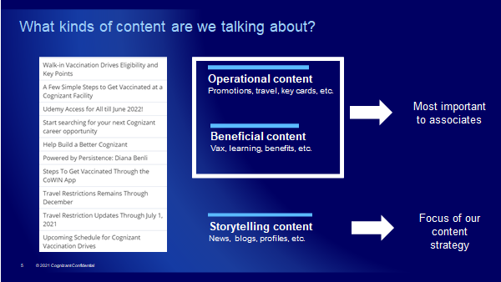

We place content into three categories:

1. **Operational content**: These are updates and tactical messages that associates NEED. Examples include: Details on the next promotion cycle, new travel approval processes, return-to-office plans, etc. If the Chennai office required all associates to get new key cards, it would fall into this category.
2. **Beneficial content**: These are the updates and tactical messages that associates WANT. Examples include COVID-19 vaccination drives, learning and upskilling opportunities, new health benefits or added vacation days, etc. If we decided to give everyone in the company a new iPhone, the announcement would fall into this category.
3. **Storytelling**: This is news, blogs, leader videos, associate profiles, thought leadership, etc.

Data tells us that associates want operational and beneficial content the most. But from a content strategy standpoint, the action is clear. (If we’re offering new health benefits, we want to tell people we’re offering new benefits.) The content strategy’s purpose is to hone and refine storytelling.

**Thinking multi-channel, internally and externally:**

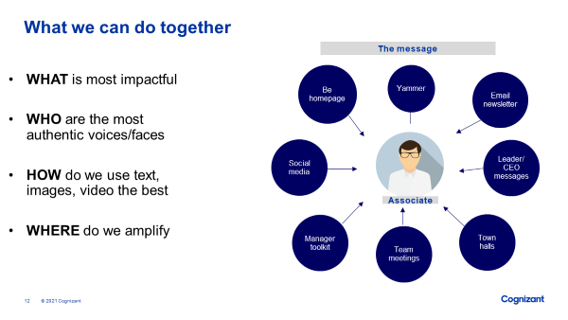

Be.Cognizant is our internal home base, but it’s never our only base. When thinking about content, we think about how it can fuel internal and external campaigns and how it can be shared across multiple channels. Associates are on LinkedIn just as much as they are on Be.Cognizant, and people need to hear messages multiple times before they sink in.

We build content to be used multiple times, in multiple ways.

**The content strategy and campaigns**

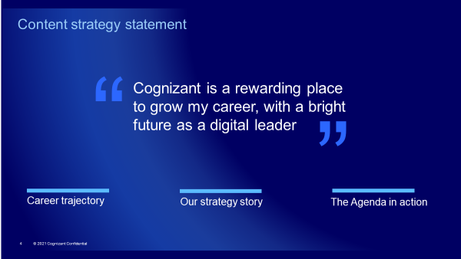

We’ve put the associate first, followed with a strong statement of fact about the future path of the company. We’re also employing a campaign mindset, so that we funnel new story opportunities into existing campaigns rather than one-off stories.

The strategy includes three pillars:

**Career trajectory**: A laser focus on showing how associates can grow in a rewarding career at Cognizant. Campaign examples include:

* I Engineer Impact (heart campaign).
* Take 5: A 5-question Q&A with associates who have an ID of 5 or lower about their Cognizant career path.
* Leader interviews about their career successes and challenges.

**Our strategy story**: Associates want to know about the strategy and direction of the company. Put simply: Are we succeeding? Rather than sharing individual stories about wins, we strive to tell an ongoing story about our strategic pillars, why we’re making those bets and whether we’re succeeding.

**The Agenda in action**: When we win, how did the teams support this win by embodying the Cognizant Agenda? How did we Work as One in different ways or Seek Data, Build Knowledge to beat the competition?

**Where does the EVP fit?**

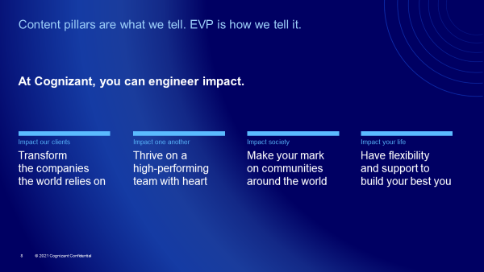

Think of the content strategy guiding *what* we tell, and the employee value proposition guiding *how* we tell it.

**General writing do’s and don’ts**

Do:

* Show how our work affects both clients *and* the customers they serve.
* Keep articles around 500 words max. Respect your audience’s time.
* Be clear and direct. Bigger words/longer sentences don’t always equal better writing.
* Put your most important point at the start. Tell readers why they should care or take action.
* Focus on results, insights or resources that deliver value for your audience.
* Share tangible, specific benefits and outcomes that associates can use in their own work.
* Break up long blocks of content with bullet points, subheads, etc.
* Use exclamation points and bold sparingly in text, such as bolding a main “you must do this” message. The only underlined text should be weblinks.
* Have someone review your writing before sending/publishing; check all links and verify that all instructions work.

Don’t:

* Name clients unless they’ve already been publicly named in a Cognizant case study or press release. Otherwise, use general language such as “a major U.S. healthcare client.”
* Tell associates what you want to say. Tell them what they need to hear.
* Use jargon that a majority of your audience wouldn’t understand. This includes abbreviations.
* Send “coming soon” messages, overpromise or stretch the truth.
* Make statements like “the crowd was enthusiastic” or “the meeting was a success”; show with examples rather than tell with general statements.
* Be aggressive or defensive when asking someone to take action.
* Use all-caps.

**Visuals:**

All Be.Cognizant articles need a main image. The size of article images should be 1108X623 pixels. Images have to be purchased or royalty-free from a service like [Unsplash](https://unsplash.com/).

Otherwise, Communications follows Marketing’s visual guidelines. Please reach out to the Marketing team with questions.

**Global Communications style entries***Internal Communications follows the Merriam Webster dictionary, Associated Press style and* [*the Thought Leadership team’s styleguide*](https://codex.cognizant.com/pages/styleGuideAndSeoBestPractices.php)*. Below are additional Internal Communications-specific style entries.*

**Associate**: Use “associate” versus “employee” when talking about someone who works at Cognizant. Associate should be lowercase, as it is a general descriptor of multiple positions and is not unique to Cognizant.

**Annual performance-based bonus**: Use this wording when referring to the March company bonus.

**Be.Cognizant**: The official name of our intranet. Use the period when referring to it by name. No quote marks, italic, etc.

**Brian Humphries:** You can refer to our CEO simply by first name in internal communications headlines and body copy when the article is mainly about him or with a photo of him. Otherwise, use his first and last name in headlines and CEO Brian Humphries in copy.

**Business Units:** Capitalize the names of Cognizant business units and practice areas (Healthcare, Digital Business, etc.). Lowercase references to the industries we serve (the healthcare and life sciences industry.) Spell out “business unit” on first reference. Lowercase “business unit” when writing about them generally.

**CEO**: Abbreviate in all instances

**CFO**: Abbreviate in all instances

**Client:** Use “client” when talking about the companies we serve. Customers are they people *they* serve. Example: “We delivered a solution to a major healthcare client that helped them process their customers’ claims 80% faster.”

**Cognizant**: Feel free to use first-person “we” or “us” in internal communications to describe the company, your team or associates. Let message clarity and conversational tone be your guide.

**The Cognizant Agenda**: Uppercase the Cognizant Agenda (note that “the” is lowercase).

Also uppercase: Purpose, Vision, Bold Moves and Values in all instances, including singular instances (My favorite Value is…). List them in that order.

The items within the Agenda – our Purpose statement, specific Values or individual Bold Moves, etc. – should be sentence style and in italics.

Examples:  
At Cognizant, we aim to *create conditions for everyone to thrive* and we want to ensure your work schedule does not inhibit your personal right to vote.

When we *work as one* to provide innovative value to our clients, everyone is a winner.

Our Purpose – *we engineer modern businesses to improve everyday life* – is the lens we use to make decisions.

**Dates**: Use American month-day-date style. Follow AP style: Abbreviate months when part of a full date. Spell out in other instances. Don’t use the year unless necessary for clarity or it’s a formal legal message.  
*Examples:*Feb. 21, 2019  
February 21

**Days of the week**: If you’re referencing an event less than a week in the future in an internal communication, you can use a specific day of the week, with the month/day in parenthesis afterward. Avoid “today” or “tomorrow” unless you’re communicating to an isolated group. Keep in mind that Cognizant is a global company and that someone’s today can be someone else’s tomorrow.  
*Examples*:   
Please submit your form by Thursday (January 16).

**Digital Battlegrounds**: Capitalize both the term and the specific areas (Data, Internet of Things, etc.). Avoid including a number (four Digital Battlegrounds), as the number could change.

**Email subject lines:** Use sentence style. Capitalized the first word and proper nouns. No punctuation at the end unless it’s a rare situation that calls for multiple sentences.  
*Example:*Please join us for a video town hall with Brian  
The time has come. Register for the video town hall with Brian.

**Fit for Growth:** Capitalize.

**Gender**: Refer to people by their desired name and gender pronouns (he, she, they, etc.).

**Headlines**: Be.Cognizant headlines follow sentence style for capitalization. Be.Cognizant subheads are also sentence style.

*Example:*  
Cognizant is making Aston Martin better, on and off the track

There is no punctuation at the end of a headline or subhead except for rare instances where you are creating two sentences. (Example: They had reason to celebrate. They won the lottery.) Avoid question mark headlines. Headlines should answer a question, not pose one. (Unless you specifically want feedback.)

**Horizontal:** Lowercase when referring to Cognizant’s structure.

**Hyperlinks**: Links should explain where someone is going and what they will get. Do not use “click here” or type out the URL. Example: For more on open enrollment, <visit the Cognizant Benefits page.>

**Internet of Things:** Capitalize, as it’s one of our Digital Battlegrounds.

**Job titles**: Capitalize specific job titles regardless of where or how they appear.

Examples:  
Digital Business President Jane Jackson delivered the report  
Carl Jones, a Director in Digital Operations, said the project will be complete in two weeks  
This event is specifically for Directors and Senior Directors.

(Note: When speaking about associates generally as a group of Cognizant employees, “associates” is lowercase.)

**Mankind:** Use “humankind” and other gender-neutral language for terms for similar words.

**Names**: Use first and last name on first reference, then first name afterward. Put names in bold in communications only if the communication is name-heavy, such as in an organizational announcement.

**Photo captions:** Use captions when the context of a photo is not immediately clear. In photos of two to five people, list their names with a direction, such as “Left to right:” Photos of more than five people can have a general caption such as “A group of associates from Life Sciences…”

**Subheads:** Subheads and secondary headlines should be sentence style with no punctuation.

**Trademarks**: To avoid formatting issues or distracting the reader’s eye, only use trademark/reserved symbols if a contract states it must be used specifically in internal communications.

**Vertical:** Lowercase when referring to Cognizant’s structure.

**Workstream**: One word when talking internally about CEO Brian Humphries’ six focus areas for our transformation.

**People-first language**

Generally, it is best practice to put the person *before* the disability. For example, say a person with a hearing impairment, not a deaf person. A person who has autism is much more respectful than saying an autistic. This also applies when you’re describing a group of people with disabilities. Do not label a group of individuals as “the disabled” which puts the focus on the disabilities instead use the term “people with disabilities.”

**Identify first language**

In society and the media, it is often the case that people with disabilities tend to be over-emphasized negatively. Most people with disabilities do not suffer them for example a person with cerebral palsy does not suffer from their disability they simply have it. The term suffers incorrectly implies that people with disabilities are in constant pain or the quality of life is always compromised. Additionally, the person who uses a world wheelchair is not confined or bound to a wheelchair. That implies the wheelchair is something like a punishment instead of a mobility aid.

[Visit Unite on Be.Cognizant to learn more](https://be.cognizant.com/sites/diversity-inclusion/unite/SitePageModern/856604/unite).